**PayUMoney Integration Document**



**4th Floor, Pearl Towers**

**Plot 51, Sector 32**

**Gurgaon, 122002**

**Phone: 0124-6624956**

**0124-6624970**

**Email:** [techsupport@payumoney.com](mailto:techsupport@payumoney.com)

# Overview

This note describes the how to do the technical integration between PayUMoney Payment Gateway and your website in respect of powering online transactions.

# PayUMoney Payment Gateway

PayUMoney offers electronic payment service to your website through its various partnerships with banks and payment instrument companies. Through PayUMoney, your clients would be able to make electronic payments through credit card, debit card and online net banking account

PayUMoney also offers an online interface where the merchant can view transaction details, settlement reports, analytic reports etc. This online interface can be accessed through [https://www.payumoney.com](https://www.payupaisa.com) by using the username and password provided to you.

# Payment Process Flow

The following diagram explains how the customer makes the payment and how the process flows:

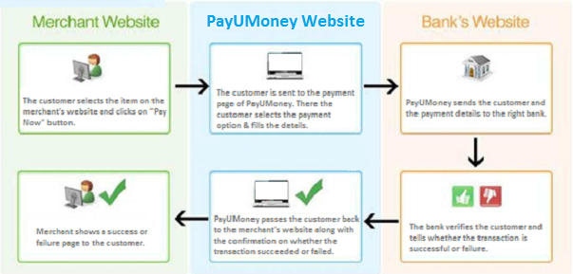

**Step 1**: The consumer selects the product on your website and clicks on “Pay Now” button.

**Step 2**: The consumer is then taken from your website to the transaction page of www.payumoney.com where in all the payment related details are entered by the consumer.

**Step 3**: Payumoney.com.com redirects the consumer to Visa, MasterCard or the relevant bank for the next level of authorization.

**Step 4**: The Bank/Visa/MasterCard authorizes and confirms the transaction.

**Step 5**: The consumer is sent back to PayUMoney.

**Step 6**: PayUMoney sends the consumer back to your website along with the transaction status.

# Status of a Transaction

A transaction can have several different statuses as explained below.

## Not Started – The transaction has not been started yet.

1. **Initiated** – The transaction has been started but not completed.
2. **Money With PayUMoney**– The transaction was successful and the transaction amount is with PayUMoney.
3. **Under Dispute** – A dispute for the transaction has been raised.
4. **Refunded** – The entire amount of the transaction has been refunded.
5. **Partially Refunded** – A part of the amount of the transaction has been refunded.
6. **Bounced** – Incomplete or no details provided at PayUMoney payment page.
7. **Failed** – The transaction didn’t complete due to a failure.
8. **Settlement in Process** – Settlement for the transaction is in process.
9. **Completed** – The transaction is settled and complete.

# Settlement process

Settlement is the process by which the money gets transferred from the customer to the bank account of the merchant. PayUMoney follows a T+2 settlement scheme where T is the date on which the transaction is captured.

There is a reconciliation process at PayUMoney. On the next day, after you have captured the transactions, PayUMoney will reconcile the online transactions with the credits received based on batch files received from the banks. After reconciling, we will generate a report and payment will be made for all the transactions for which payment has been received from the bank. All the details will be visible to you in the online interface.

# Technical Integration

In the payment process flow, to move the consumer from Step 1 to Step 2, a POST request needs to be generated by merchant to the following URL

## Production server:

POST URL: <https://secure.payu.in/_payment>

To post successfully on production server, your merchant application status should be approved and you should use the key sent to you by PayUMoney after confirming the approval of your application.

## Test server:

POST URL: <https://test.payu.in/_payment>

**Test Key** & **Salt** – Please sign up for a merchant account on <https://test.payumoney.com> and contact your account Manager or [techsupport@payumoney.com](mailto:techsupport@payumoney.com) for activating the test key and salt for this account.

**Test Card Name**: any name

**Test Card Number**: 5123456789012346

**Test CVV**: 123

**Test Expiry**: May 2017

In order to integrate your website with PayUMoney, you can use our test server and test key if your application is not yet approved.

**Please note that the Key and Salt for test server are different and should be used only with test server.**

**The purpose of the test server & Key-Salt is to enable you to integrate and do test transaction. It cannot be used for actual transactions from your website.**

**Key notes and terms**

1. **Key (MerchantID)** : This ID is generated at the time of activation of your site and helps to uniquely identify you to PayUMoney.

2. **TxnID**: A Unique alphanumeric Transaction ID generated by you to uniquely identify a transaction. The TxnID should be unique since it would allow you to identify the transaction easily.

3. **Amount:** Amount is the total amount of the transaction (greater than 0) in INR, without a currency symbol or other non-numeric character. Only a decimal allowed.

4. **MIHPayID**: Unique ID generated for a transaction by PayU.in

5. **Hash (Checksum)**: This refers to a random numeric string generated using a mathematical algorithm to ensure that data is not tampered along the way. Let’s say a message has to be sent from location X to Y. X and Y both mutually agree on a Secret Key called “Salt” that only both of them possess. A checksum is generated by a mathematical function using the message and the Salt as input. This checksum is then sent along with the message to Y. Y then recalculates this checksum using the Salt and the same algorithm. If the checksum that Y calculates is different from the checksum that X passed then the data was tampered along the way and is thus rejected.

*The Checksum algorithm used is SHA2 which is globally well known algorithm. To need help with implementation, feel free to call us, mail us or use Google to find the desired function library for your implementation. Some example codes are also mentioned at the end of this document*

6. **Product Info**: It is a json encoded array of various payment parts where each part contains ‘name’, ‘description’, ‘value’ and ‘isRequired’ fields. JSON (JavaScript Object Notation) is a lightweight data-interchange format. It is easy for humans to read and write. It is easy for machines to parse and generate.

It is based on a subset of the JavaScript Programming Language. JSON is a text format that is completely language independent.

**The format of the json encoding for productinfo is as follows:-**

Productinfo = {“paymentParts”:[{

"name":"abc",

"description":"abcd",

"value":"500",

"isRequired":"true",

“settlementEvent” : “EmailConfirmation”

},

{

"name":"xyz",

"description":"wxyz",

"value":"1500",

"isRequired":"false",

“settlementEvent”: “EmailConfirmation”

}],

{“paymentIdentifiers”:[{

"field":"CompletionDate",

"value":"31/10/2012”

},

{

"field":"TxnId",

"value":"abced"

}]}

|  |  |
| --- | --- |
| Param Name | Description |
| Name | Name of Payment Part |
| Description | Description of the payment part |
| Value | Value |
| isRequired | True |
| settlementEvent | EmailConfirmation |

**NOTE:** **You may choose to pass a simple string (static or dynamic) in the ‘productinfo’ field.**

The parameters to post are described below:

|  |  |  |  |
| --- | --- | --- | --- |
| S.No | Variable | Importance | Description |
| 1 | Key | Compulsory | Merchant Key provided by PayUMoney |
| 2 | Txnid | Compulsory |  |
| 3 | amount | Compulsory | Payment amount (Type cast the amount to float) |
| 4 | productinfo | Compulsory | Product Description |
| 5 | firstname | Compulsory | (only alphabets a-z are allowed) |
| 6 | lastname |  | (only alphabets a-z are allowed) |
| 7 | address1 |  | (Length of address1 and address2 must not more than 100 characters each and the allowed  characters are only) A TO Z, a to z, 0 to 9, @, - (Minus), _ (Underscore), / (Backslash), (Space), (Dot) |
| 8 | address2 |  | (allowed characters are same as for address1) |
| 9 | City |  | (allowed characters are same as for address1) |
| 10 | State |  | (allowed characters are same as for address1) |
| 11 | country |  | (allowed characters are same as for address1) |
| 12 | zipcode |  | Numeric value only |
| 13 | email | Compulsory | Customer’s email Id |
| 14 | phone | Compulsory | mobile number or landline number (numeric value only) |
| 15 | udf1 |  | user defined field 1 |
| 16 | udf2 |  | user defined field 2 |
| 17 | udf3 |  | user defined field 3 |
| 18 | udf4 |  | user defined field 4 |
| 19 | udf5 |  | user defined field 5 |
| 20 | Surl | Compulsory | Success URL where PayUMoney will redirect after successful payment. |
| 21 | Furl | Compulsory | Failure URL where PayUMoney will redirect after failed payment. |
| 22 | hash(Checksum) | Compulsory | Hash or Checksum  =sha512(key|txnid|amount|productinfo|firstname|email|udf1|udf2|udf3|udf4|udf5||||||salt)  (SALT will be provided by PayUMoney) |
| 23 | service_provider | Compulsory | payu_paisa |

# Important Things to remember:

Allowed characters for address1, address2, city, state, country, productinfo, email, and phone are:

1. Characters: A to Z, a to z, 0 to 9

2. - (Minus)

3. _ (Underscore)

4. @ (At the Rate)

5. / (Slash)

6. (Space)

7. . (Dot)

If the merchant sends any other special characters then they will be automatically removed. The address will consider only first 100 characters.

# Formula for checksum before transaction

sha512 (key|txnid|amount|productinfo|firstname|email|udf1|udf2|udf3|udf4|udf5||||||<SALT>)

SALT will be provided by PayUMoney. The algorithm used is SHA2 which is globally well known algorithm. To need help with implementation, feel free to call us, mail us or use Google to find the desired function library.

**Return Parameters**

|  |  |  |
| --- | --- | --- |
| S. no. | Variable | Description |
| 1 | mode: | 'CC' for credit-card / ‘DC’ for Debit Card / 'NB' for net-banking  String value. Limit 2 characters. |
| 2 | status: | success/failure. String value. Limit 7 characters. |
| 3 | key: | Merchant key provided by PayUMoney. Alphanumeric string value. Limit 5-9 characters. |
| 4 | txnid: | Merchant Transaction ID. String value. Limit 30 characters. |
| 5 | amount: | Original amount send by merchant. String value. Limit 30 characters. |
| 6 |  |  |
| 7 | productinfo: | <Self Explanatory> String value. Limit 100 characters. |
| 8 | firstname: | <Self Explanatory> String value. Limit 20 characters. |
| 9 | lastname: | <Self Explanatory> String value. Limit 20 characters. |
| 10 | address1: | <Self Explanatory> String value. Limit 100 characters. |
| 11 | address2: | <Self Explanatory> String value. Limit 100 characters. |
| 12 | city: | <Self Explanatory> String value. Limit 30 characters. |
| 13 | state: | <Self Explanatory> String value. Limit 30 characters. |
| 14 | country: | <Self Explanatory> String value. Limit 30 characters |
| 15 | zipcode: | <Self Explanatory> String value. Limit 6 characters. |
| 16 | email: | <Self Explanatory> String value. Limit 50 characters. |
| 17 | phone: | <Self Explanatory> String value. Limit 11 characters. |
| 18 | udf1: | <Self Explanatory> String value. Limit 100 characters. |
| 19 | udf2: | <Self Explanatory> String value. Limit 100 characters. |
| 20 | udf3: | <Self Explanatory> String value. Limit 100 characters. |
| 21 | udf4: | <Self Explanatory> String value. Limit 100 characters. |
| 22 | udf5: | <Self Explanatory> String value. Limit 100 characters. |
| 23 | hash: | Hash must be verified before confirmation of transaction. String value. Limit- Fixed 128 everytime. |
| 24 | Error: | If transaction failed, then reason of failure (Refer to APPENDIX at the end of the document). String value. Limit 4 characters. |
| 25 | PG_TYPE | Payment gateway type used in transaction. String value. Limit 10 characters. |
| 26 | bank_ref_num | Reference number for the payment gateway (received in PG_TYPE). String value. Limit 20 characters. |
| 27 | payuMoneyId | Unique payment ID. String value. Incremental value. Generally 8 characters. To be used as the reference number and for mapping with the txnid generated at your end. |
| 28* | additionalCharges | This is an optional return param that will be posted from our end if your PayUMoney account is on convenience fee model. |
|  |  |  |
|  |  |  |

**For Wordpress Charitable Plugin:-**

**Step 1:** Go to your WordPress Admin Panel login page. Enter the credentials and you will reach the dashboard.

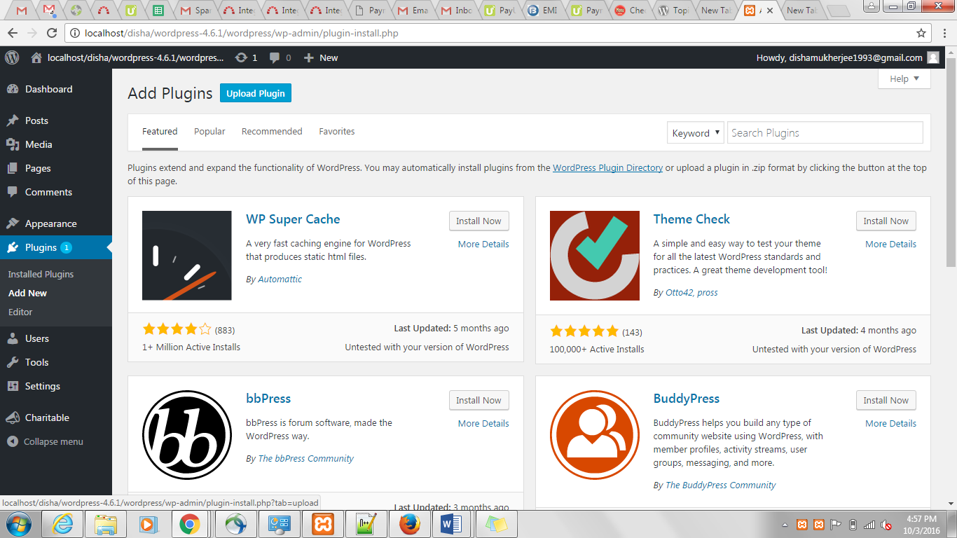

**Step 2:** Hover the mouse on “**Plugins**” and click on “**Add New**”. You should get to the next page which is mentioned below –



**Step 3:** Click on Upload, browse and select the Woo-commerce **Plugin**. Click on “**Install now**” after this. Once installed, click on “**Activate Plugin**”.

**Step 4:** Just like the above step install the PayUMoney Plugin and activate it. See the screenshot below –

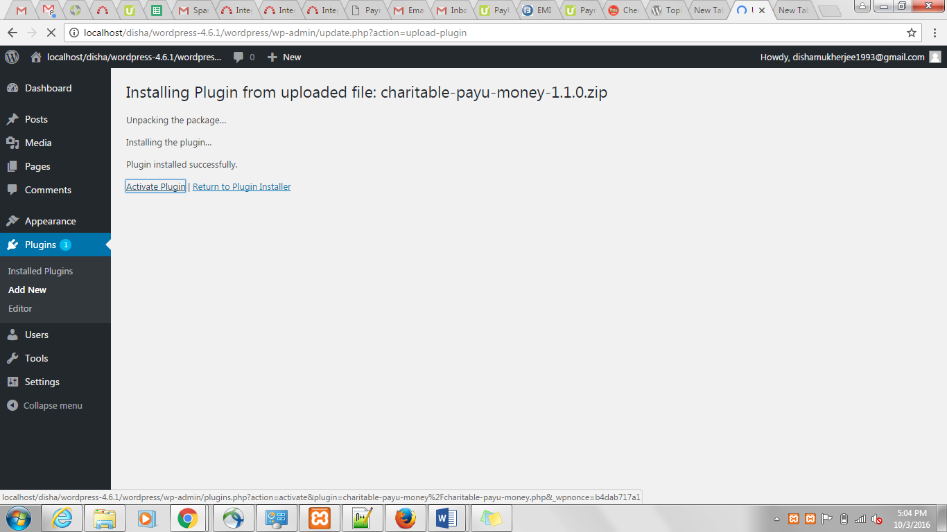

**Step 5:** Now go to **Settings** in **Charitable** and click on **Payment Gateways** as shown below –

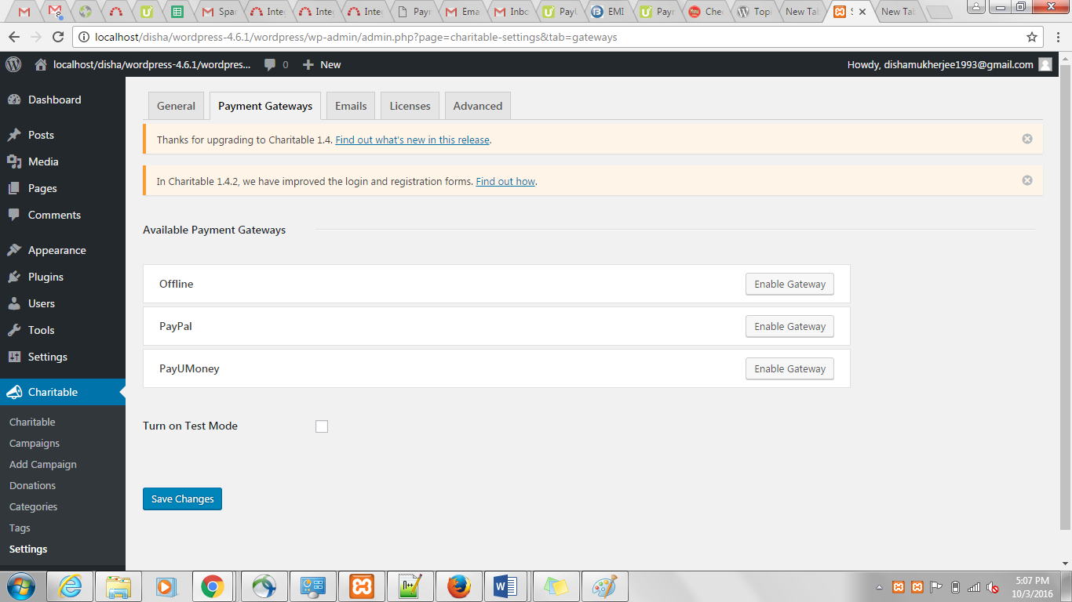

**Step 6:** Click on “**PayUMoney**” Enter the following details –

(a) If you want to use the demo -

**Test Merchant Key :** Get it from seller dashboard of test account.

**Test Merchant SALT :** Get it from seller dashboard of test account.

(b) When you wish to go live –

**Live Merchant Key** – Enter the Merchant Key supplied to you (Please don’t enter the Merchant ID supplied to you).

**Live Merchant SALT** - Enter the Merchant Salt supplied to you.

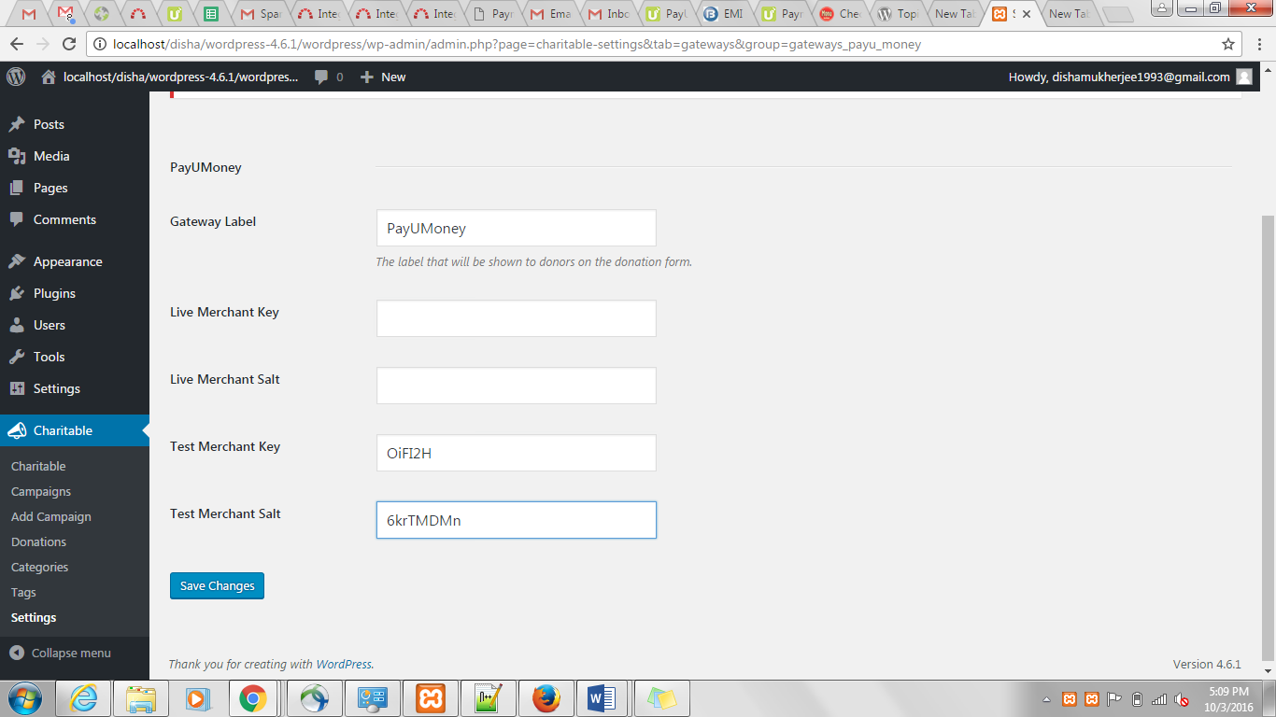

**Step 7 :** Click on “**Save Changes**” and try the transaction.

Also, you may use the following credit card credentials for successful transactions in Test mode –

• Credit Card Number – 4012001038443335

• Name on the Card – Any name

• Card Expiry – May, 2017

• CVV – 123

**APPENDIX**

|  |  |
| --- | --- |
| Error Message | Codes |
| Address_failure | e314 |
| Address_invalid | e304 |
| Amount_difference | e702 |
| Authentication_error | e303 |
| Authentication_incomplete | e335 |
| Authentication_service_unavailable | e334 |
| Awaiting_processing | e505 |
| Bank_denied | e312 |
| Bank_server_error | e208 |
| Batch_error | e216 |
| Brand_invalid | e201 |
| Card_fraud_suspected | e324 |
| Card_issuer_timed_out | e218 |
| Card_not_enrolled | e900 |
| Card_number_invalid | e305 |
| Checksum_failure | e213 |
| Communication_error | e210 |
| Curl_call_failure | e214 |
| Curl_error_card_verification | e203 |
| Curl_error_enrolled | e205 |
| Curl_error_not_enrolled | e204 |
| Cutoff_error | e206 |
| Cvc_address_failure | e315 |
| Cvc_failure | e313 |
| Duplicate_transaction | e504 |
| Expired_card | e311 |
| Expiry_date_low_funds | e336 |
| Incomplete_bank_response | e219 |
| Incomplete_data | e712 |
| Insufficient_funds | e706 |
| Insufficient_funds_authentication_failure | e719 |
| Insufficient_funds_expiry_invalid | e713 |
| Insufficient_funds_invalid_cvv | e718 |
| International_card_not_allowed | e903 |
| Invalid_account_number | e717 |
| Invalid_amount | e715 |
| Invalid_card_name | e709 |
| Invalid_card_type | e902 |
| Invalid_contact | e333 |
| Invalid_email_id | e331 |
| Invalid_expiry_date | e323 |
| Invalid_fax | e332 |
| Invalid_login | e327 |
| Invalid_pan | e707 |
| Invalid_pin | e710 |
| Invalid_transaction_type | e207 |
| Invalid_user_defined_data | e711 |
| Invalid_zip | e714 |
| Issuer_declined_low_funds | e329 |
| Lost_card | e310 |
| Merchant_invalid_pg | e200 |
| Network_error | e211 |
| No_bank_response | e209 |
| No_error | e000 |
| Not_captured | e337 |
| Parameters_mismatch | e328 |
| Password_error | e326 |
| Payment_gateway_validation_failure | e330 |
| PayUMoney_api_error | e600 |
| Permitted_bank_settings_error | e716 |
| Pin_retries_exceeded | e708 |
| Prefered_gateway_not_set | e800 |
| Receipt_number_error | e704 |
| Reserved_usage_error | e215 |
| Restricted_card | e325 |
| Retry_limit_exceeded | e901 |
| Risk_denied_pg | e307 |
| Secure_3d_authentication_error | e317 |
| Secure_3d_cancelled | e302 |
| Secure_3d_card_type | e322 |
| Secure_3d_format_error | e319 |
| Secure_3d_incorrect | e301 |
| Secure_3d_not_enrolled | e316 |
| Secure_3d_not_supported | e318 |
| Secure_3d_password_error | e300 |
| Secure_3d_server_error | e321 |
| Secure_3d_signature_error | e320 |
| Secure_hash_failure | e700 |
| Secure_hash_skipped | e701 |
| Server_communication_error | e212 |
| System_error_pg | e309 |
| Tranportal_id_error | e217 |
| Transaction_aborted | e502 |
| Transaction_cancelled | e503 |
| Transaction_failed | e308 |
| Transaction_invalid | e202 |
| Transaction_invalid_pg | e306 |
| Transaction_number_error | e703 |
| Unknown_error | e501 |
| Unknown_error_pg | e500 |
| User_profile_settings_error | e705 |

**You can get in touch with us:**

**Email:** [techsupport@payumoney.com](mailto:techsupport@payumoney.com)